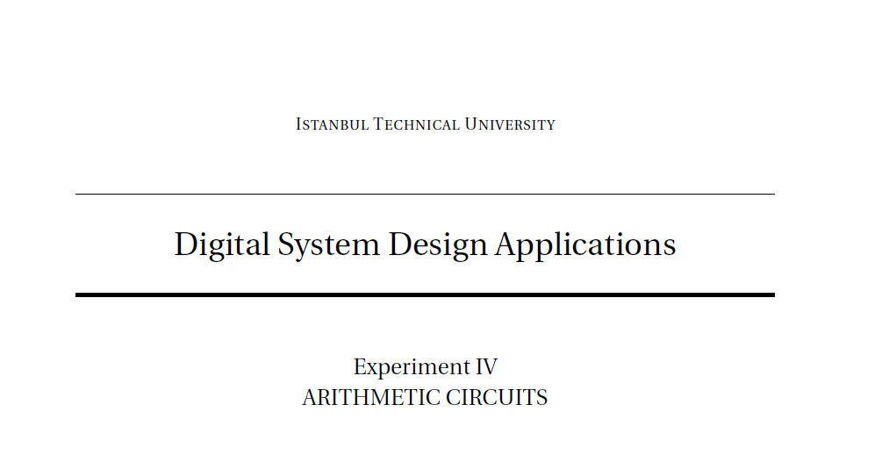

TERM PROJECT

Project Goal: Designing a combinational circuit which realizes y=arctanh(x)

BEHİÇ ERDEM

040170213